**Kubernetes Custom Resources and Custom Resource Definitions**

In the ever-evolving landscape of Kubernetes, the ability to extend the platform’s capabilities beyond its built-in resources is essential. Custom Resources (CRs) and Custom Resource Definitions (CRDs) offer a powerful mechanism for defining and managing custom resources tailored to specific application requirements. In this blog post, we’ll delve into the world of Kubernetes CRs and CRDs, exploring their significance, use cases, and practical implementations.

**Understanding Kubernetes Custom Resources and CRDs:**

Kubernetes Custom Resources (CRs) are extensions of the Kubernetes API that represent custom objects or resources tailored to specific use cases or applications. These resources can encapsulate complex configurations, application settings, or operational parameters that are not natively supported by Kubernetes.

Custom Resource Definitions (CRDs) define the structure and behavior of Custom Resources, specifying their schema, validation rules, and API endpoints. CRDs allow users to extend the Kubernetes API with custom resource types, enabling seamless integration of custom logic and functionality into Kubernetes clusters.

**Why Custom Resources and CRDs Matter:**

Custom Resources and CRDs offer several benefits for Kubernetes users, including:

* Enhanced Extensibility: CRs and CRDs enable Kubernetes clusters to be extended with custom resource types that address unique requirements or domain-specific needs.
* Simplified Management: By encapsulating complex configurations or application logic into Custom Resources, administrators can simplify management and deployment tasks, reducing operational overhead and improving efficiency.
* Improved Automation: CRs and CRDs can be leveraged to automate common tasks, such as deploying applications, configuring services, or managing infrastructure components, using familiar Kubernetes tools and workflows.

**Real-Life Use Cases:**

Custom Resources and CRDs are used in various scenarios within Kubernetes environments, including:

* Application Deployment: Define custom resource types to represent application deployments, including configuration settings, scaling parameters, and deployment strategies.
* Service Discovery: Create custom resource types for service discovery, allowing applications to dynamically register and discover services within the cluster.
* Configuration Management: Define custom resource types to manage application configurations, environment variables, and secrets in a declarative and Kubernetes-native manner.

**Practical Implementation**

In a hands-on demonstration, let’s walk through the process of creating and using Custom Resources and CRDs in a Kubernetes cluster:

Defining CRDs: Use Kubernetes manifests to define Custom Resource Definitions, specifying the schema, validation rules, and API endpoints for custom resources.

apiVersion: apiextensions.k8s.io/v1  
kind: CustomResourceDefinition  
metadata:  
 # name must match the spec fields below, and be in the form: <plural>.<group>  
 name: crontabs.stable.example.com  
spec:  
 # group name to use for REST API: /apis/<group>/<version>  
 group: stable.example.com  
 # list of versions supported by this CustomResourceDefinition  
 versions:  
 - name: v1  
 # Each version can be enabled/disabled by Served flag.  
 served: true  
 # One and only one version must be marked as the storage version.  
 storage: true  
 schema:  
 openAPIV3Schema:  
 type: object  
 properties:  
 spec:  
 type: object  
 properties:  
 cronSpec:  
 type: string  
 image:  
 type: string  
 replicas:  
 type: integer  
 # either Namespaced or Cluster  
 scope: Namespaced  
 names:  
 # plural name to be used in the URL: /apis/<group>/<version>/<plural>  
 plural: crontabs  
 # singular name to be used as an alias on the CLI and for display  
 singular: crontab  
 # kind is normally the CamelCased singular type. Your resource manifests use this.  
 kind: CronTab  
 # shortNames allow shorter string to match your resource on the CLI  
 shortNames:  
 - ct



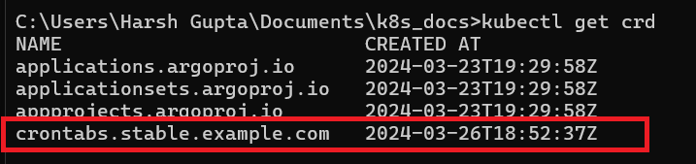

Creating Custom Resources: Use kubectl or Kubernetes client libraries to create instances of Custom Resources based on the defined CRDs, providing values for custom fields and parameters.

apiVersion: "stable.example.com/v1"  
kind: CronTab  
metadata:  
 name: my-new-cron-object  
spec:  
 cronSpec: "* * * * */5"  
 image: my-awesome-cron-image



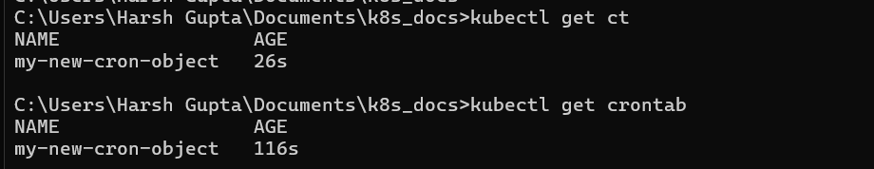

Managing Custom Resources Use Kubernetes controllers to manage Custom Resources, including querying, updating, or deleting resource instances as needed.

**Conclusion:**

In conclusion, Kubernetes Custom Resources and Custom Resource Definitions offer a flexible and powerful mechanism for extending the capabilities of Kubernetes clusters. By defining custom resource types tailored to specific use cases or applications, organizations can enhance extensibility, simplify management, and improve automation within their Kubernetes environments. Embrace the versatility of CRs and CRDs and unlock new possibilities for innovation and customization in Kubernetes.